**CSE523** Machine Learning

Project: Shipment Price Prediction

Weekly Project Report: March 17, 2023

Team: **Revolution**

|  |  |
| --- | --- |
| Team Members | Enrolment-ID |
| Deep Patel | AU2040250 |
| Roshni Navdiya | AU2040114 |
| Aditya Padhariya | AU2040151 |
| Keval Parmar | AU1940133 |



* **Task Performed this week:**

1. Implemented Gradient boost model.
2. Implemented decision tree regression model.
3. using freight cost parameter count of shipment is calculated across countries.
4. shipment mode count is also calculated.

* **Outcomes of the tasks performed:**

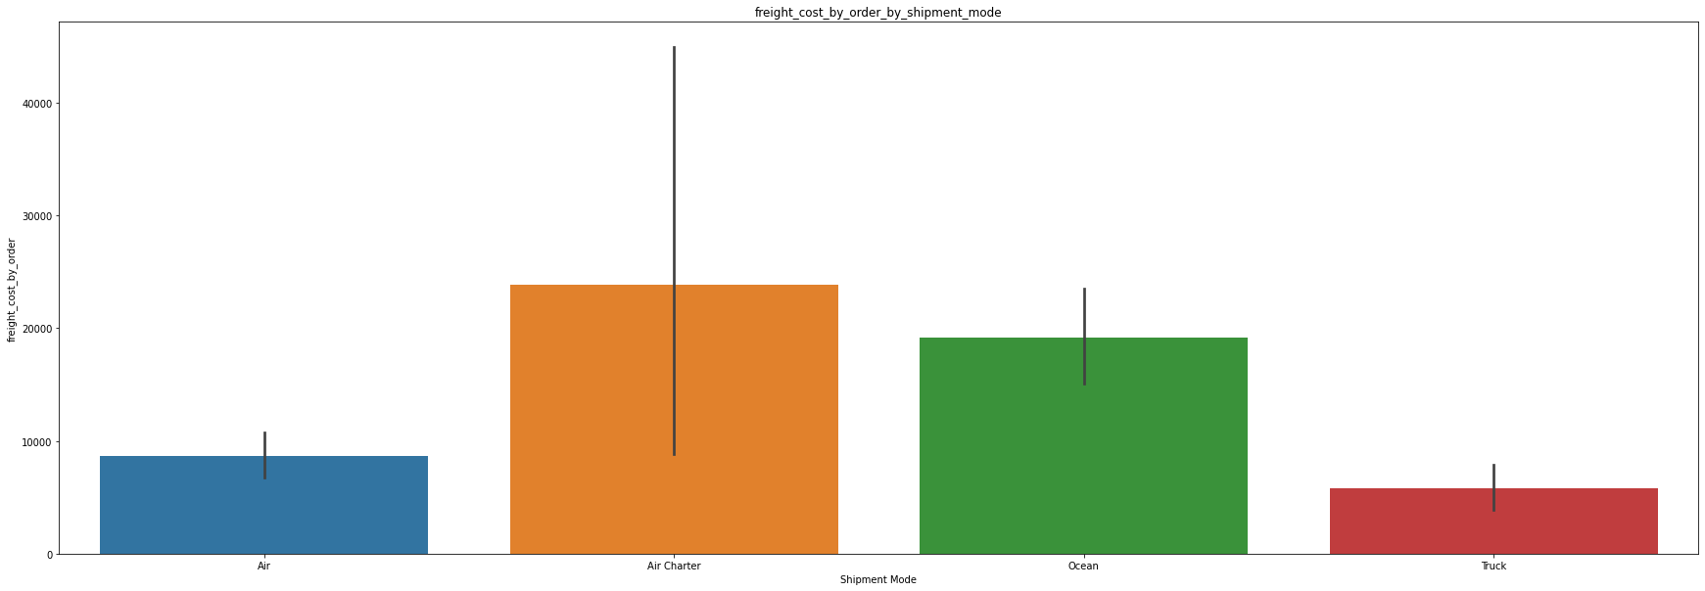

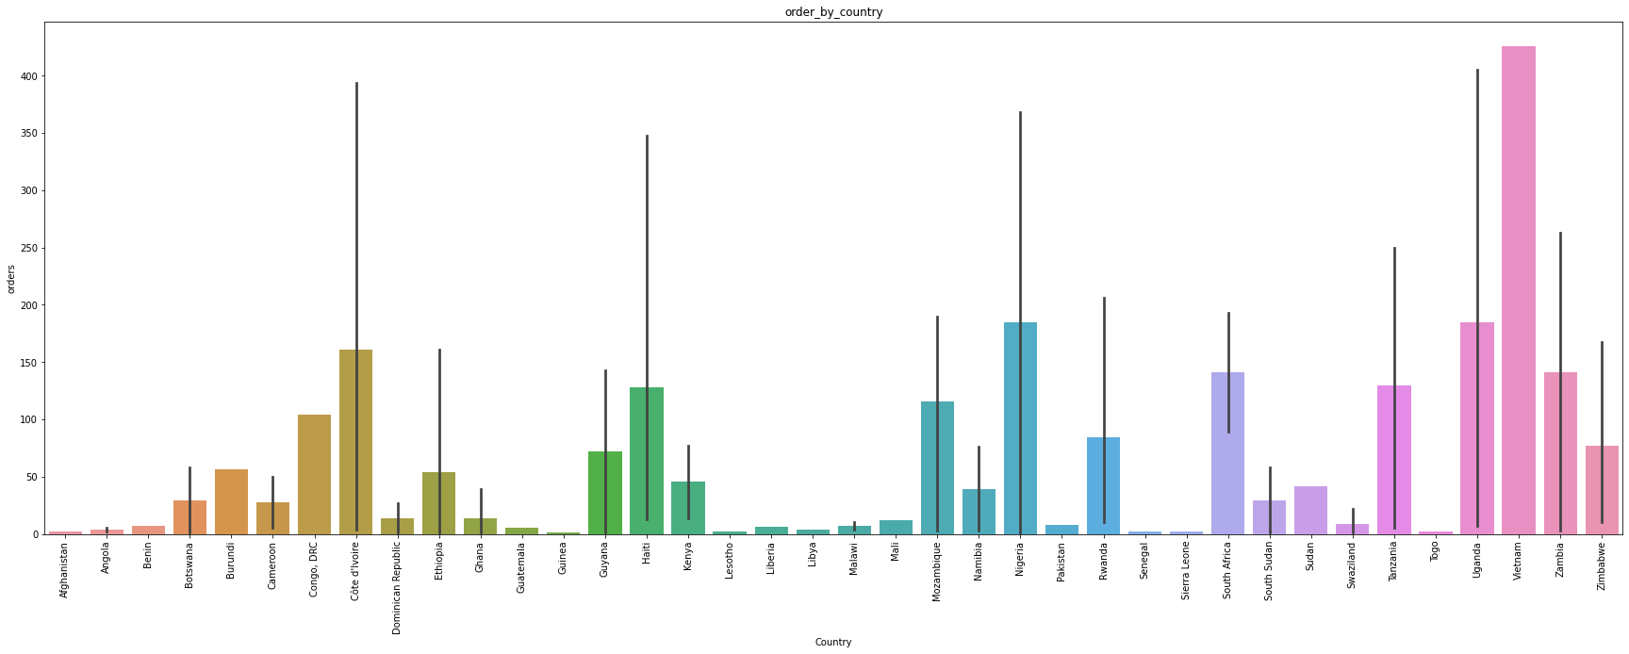

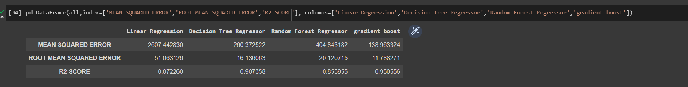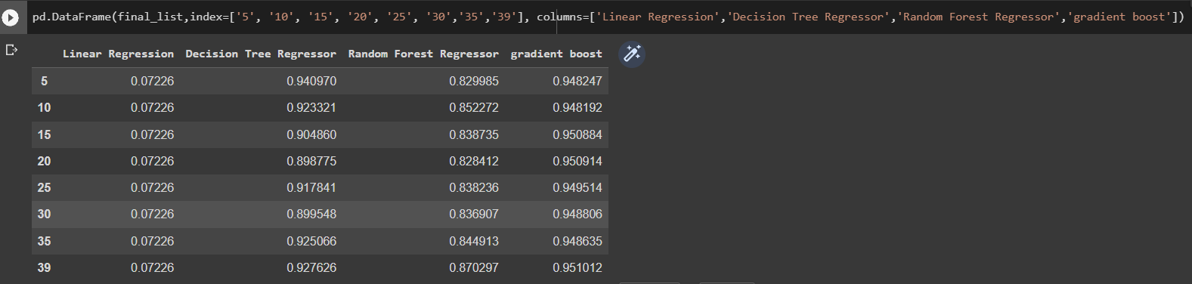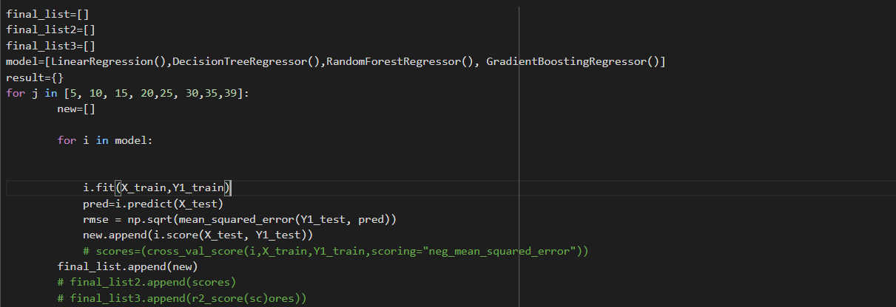

* **Tasks to be performed in the upcoming week:**

1. Will be calculating adjusted R2 value to finally decide which machine learning algorithm to use.
2. Test run the selected model on the selected parameters.